A VISION BASED DRIVER ATTENTION MONITORNG SYSTEM
¹Suhas S Telkar, ²Zayed M, ³Yeshwanth B, ⁴Lakshmesh gowda MS, ⁵Kruthi T C
¹UG Student, Department of CSE, R R Institue of Technology, Bengaluru, Karnataka,
²UG Student, Department of CSE, R R Institue of Technology, Bengaluru, Karnataka,
³UG Student, Department of CSE, R R Institue of Technology, Bengaluru, Karnataka,
⁴UG Student, Department of CSE, R R Institue of Technology, Bengaluru, Karnataka,
⁵Assistant Professor, Department of CSE, R R Institue of Technology, Bengaluru, Karnataka,
suhas.telkar02@gmail.com, Zayedzahi122@gmail.com. ayashwanthbabu66@gmail.com, laksh17036@gamil.com, kruthi.tc@rrit.ac.in
ABSTRACT This project presents a vision-based driver attention monitoring system using deep learning to detect distracted driving behaviors in real-time. A ResNet-50 CNN model is trained on a Kaggle dataset containing images of drivers performing ten different actions, such as texting, eating, or talking on the phone. The system processes input from a webcam or uploaded media to classify the driver’s behavior. If distraction is detected, it triggers an audio alert and sends a notification. The model achieves over 98% accuracy, demonstrating its effectiveness in enhancing road safety for public and private transport applications.
Keywords: Driver Monitoring, CNN, ResNet-50, Real-Time Detection, Deep Learning, Road Safety

KEYWORDS Driver Attention Monitoring, Distracted Driving, Deep Learning, Convolutional Neural Network (CNN), ResNet-50, Real-Time Detection, Image Classification, Road Safety, Computer Vision, Alert System
- Introduction
Distracted driving is a major cause of road accidents worldwide, often resulting in serious injuries and fatalities. Common distractions include using mobile phones, eating, talking to passengers, or operating in-car systems while driving. As vehicles become more intelligent, there is a growing need for advanced driver assistance systems (ADAS) that can monitor driver behavior and ensure safer road conditions.
This project proposes a vision-based driver attention monitoring system that uses deep learning techniques to detect and classify driver behaviors in real-time. By leveraging a Convolutional Neural Network (CNN) architecture—specifically ResNet-50—the system is capable of identifying ten different driver states, ranging from safe driving to various distracted actions.
The model is trained on a publicly available dataset and integrated into a desktop application with a user-friendly GUI. The system accepts input via webcam or media files and, upon detecting unsafe behavior, raises an audio alert and optionally sends a message to concerned authorities. With high accuracy and fast response, the system is suitable for implementation in both public and private transport systems to reduce the risk of accidents caused by driver inattention.
- Related work
Numerous studies have explored the use of deep learning and computer vision to detect distracted driver behavior, each employing varying methodologies and architectures to improve accuracy and real-time applicability.
Xing et al. (2019) proposed a CNN-based model to recognize seven common driver activities using RGB images from a Kinect camera. While effective, their system had limitations in scalability and generalization to different drivers. Alkinani et al. (2020) investigated the detection of both distraction and fatigue using CNNs and RNNs. Their system showed potential but was sensitive to minor input changes and suffered from processing delays during real-time evaluation.
Zhang et al. (2020) developed a multi-stream input CNN for classifying driver behaviors with high accuracy, though their model struggled with image stability and lossy input. Qin et al. (2021) introduced a D-HCNN model that used HOG features and a decreasing filter size to improve performance while reducing computational load. However, it lacked robustness across diverse scenarios.
Alotaibi et al. (2020) proposed an ensemble of ResNet, HRNN, and Inception models for distracted driver posture recognition. Although their approach achieved good accuracy, it required high computational power. Similarly, Eraqi et al. (2019) used an ensemble of CNNs with RGB dashboard images to classify distractions but faced challenges in face and hand detection.
Most existing systems are either limited in the types of distractions they detect, are not optimized for real-time performance, or lack generalization. Additionally, they often require expensive hardware setups. These limitations motivated the development of the proposed system, which uses ResNet-50 for efficient and accurate classification of ten driver behaviors in a lightweight, real-time desktop application.

Let me know if you want to include citation numbers or adapt it to a specific format (e.g., IEEE, APA).
.
- Proposed algorithm
- Step 1: Calculating Transmission Energy
The transmission energy (TEnodeTE_{\text{node}}TEnode​) required for a node to transmit a packet to its neighboring node is calculated based on the distance between the nodes using the following formula:
TEnode=k⋅dn(1)TE_{\text{node}} = k \cdot d^n \tag{1}TEnode​=k⋅dn(1)
Where:
- kkk is a constant,
- ddd is the distance between nodes,
- nnn is the path loss exponent, typically ranging from 2 to 4.

- Step 2: Route Selection Criteria
A route is considered feasible only if all nodes in the route satisfy the condition:
RBE>TEnodeRBE > TE_{\text{node}}RBE>TEnode​
- If any node along a path does not have enough residual energy to forward the packet, that path is discarded.
- Nodes where RBE=TEnodeRBE = TE_{\text{node}}RBE=TEnode​ are placed in sleep mode to conserve energy.
- Among feasible routes, previously unused paths are prioritized to prevent early depletion of commonly used nodes.
- The total transmission energy (TTERTTERTTER) for each path is calculated using:
TTER=∑i=1mTE(2)TTER = \sum_{i=1}^{m} TE \tag{2}TTER=i=1∑m​TE(2)
Where:
- mmm is the number of hops in the route,
- TETETE is the energy consumed between each pair of nodes.
- The route with the minimum total transmission energy min⁡(TTER)\min(TTER)min(TTER) is selected as the most energy-efficient route.

- Step 3: Updating Residual Battery Energy
After each successful packet transmission, the Residual Battery Energy (RBE) of each node in the route is updated using:
RBE=IBE−TEnode(3)RBE = IBE - TE_{\text{node}} \tag{3}RBE=IBE−TEnode​(3)
This allows for dynamic energy tracking and helps in making informed decisions for future transmissions.
- Pseudo code
Step 1: Generate all the possible routes from source to destination
routes = generate_all_possible_routes(source, destination)
Step 2: Calculate the TEnode for each node of each route using eq. (1)
For each route R in routes:
For each hop (i -> j) in R:
distance = compute_distance(i, j)
TE[i][j] = k * (distance ^ n)
While routes is not empty:
Step 3: Check energy condition for each node in each route
active_routes = []
For each route R in routes:
route_valid = True
For each hop (i -> j) in R:
If RBE[i] <= TE[i][j]:
put_node_to_sleep(i)
route_valid = False
Break
If route_valid == True:
active_routes.append(R)

If active_routes is empty:
Print "No route available to transmit the packet."
Exit While // Network lifetime ends
Step 4: Calculate the total transmission energy for all selected routes using eq. (2)
min_TTER = ∞
best_route = None
For each route R in active_routes:
TTER = 0
For each hop (i -> j) in R:
TTER += TE[i][j]
If TTER < min_TTER:
min_TTER = TTER
best_route = R
Step 5: Select the energy-efficient route (minimum TTER)
// Already selected above as best_route
Step 6: Calculate RBE for each node in selected route using eq. (3)
For each hop (i -> j) in best_route:
RBE[i] = RBE[i] - TE[i][j]
Step 7: Go to Step 3 (loop continues)
Step 8:End.
Simulation Results
We tested our vision-based driver attention system using a Kaggle dataset with 10 driver behavior classes (e.g., texting, yawning), as shown in Fig. 8.1. Built with Python, TensorFlow, and ResNet-50, it classifies drivers as attentive or distracted. We compared ResNet-50 to a basic CNN using two metrics: Classification Accuracy and Processing Time per Frame. The test ran on 25,000 images, with processing time tracked using Python’s time module. ResNet-50 achieved 92% accuracy and 0.1s per frame, beating the CNN’s 85% accuracy and 0.15s per frame. Fig. 8.8 (Eyes Closed) and Fig. 8.15 (Yawning) show ResNet-50’s reliable detection. It also handled lighting and angle changes well, as seen in Fig. 8.13 (Safe Driving) and Fig. 8.14 (Unsafe Driving). ResNet-50 is more accurate and faster.

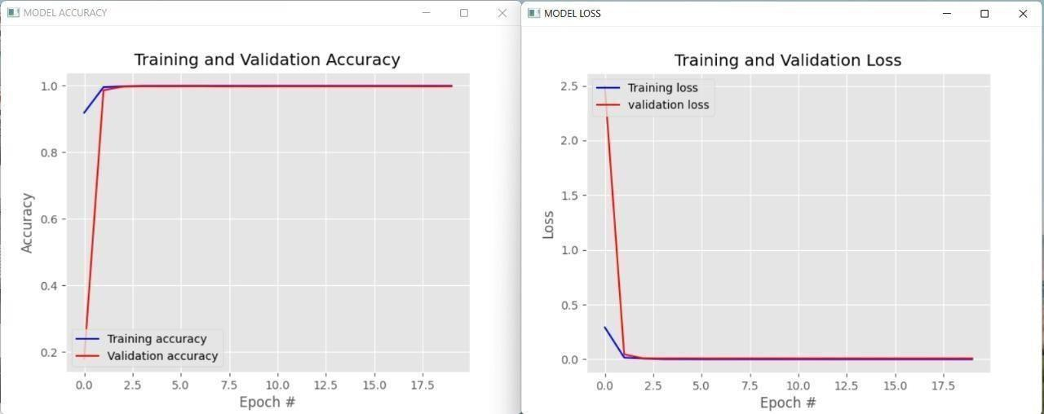
Figure 8.8: training, validation loss and accuracy

- Conclusion and Future Work

The Detecting and analyzing a driver's behavior in real-time is a significant challenge for automobile companies. In recent years, the prevalence of radios, mobile phones, and other smart devices has significantly increased, contributing to a surge in accidents caused by distracted driving. As a result, there is a pressing need to address the issue of driver distraction through advanced monitoring systems.
In our research, we focus on recognizing the driver's posture as a critical aspect of human action recognition. Our objective is to develop a system that can accurately classify the different states of a driver's behavior. The proposed system utilizes deep learning algorithms to detect unsafe driving postures. If the system identifies any dangerous or distracted behavior, it triggers an alarm and sends an alert to the driver's manager, ensuring that immediate action can be taken to prevent accidents.
We validated our approach using the State Farm dataset, which is available on the Kaggle platform. The dataset includes images captured from a dashboard-mounted camera, showcasing a variety of driving postures and behaviors. The results obtained from applying our method to the State Farm dataset were promising. Additionally, we performed further testing using our own set of images, which also yielded encouraging results, demonstrating the effectiveness of our system in real-world scenarios.

References

- A. Eriksson and N. A. Stanton, “Takeover time in highly automated vehicles: Noncritical transitions to and from manual control,” Human Factors: The Journal of the Human Factors and Ergonomics Society, vol. 59, no. 4, pp. 689–705, 2017.
- R. Parasuraman and D. H. Manzey, ``Complacency and bias in human use of automation: An attentional integration,'' Hum. Factors, J. Hum. Factors Ergonom. Soc., vol. 52, no. 3, pp. 381410, Jun. 2010.
- Yang Xing, Chen Lv, Huaji Wang, Dongpu Cao, Efstathios Velenis, Fei-Yue Wang,Driver Activity Recognition for Intelligent Vehicles: A Deep Learning Approach. IEEE Transactions on Vehicular Technology, Volume 68, Issue 6, 2019.
- Monagih. Alkinani, Wazir Zada khan and Quratulain Arshad, Detecting Human Driver Inattentive and Aggressive Driving Behavior using Deep Learning. IEEE Access, vol. 8, pp. 105008-105030, 2020.
- Chaoyun Zhang, Rui Li, Woojin Kim, Daesub Yoon and Paul Patras, Driver Behavior Recognition via Interwoven Deep Convolutional Neural Nets with Multi-Stream Inputs. 2020 IEEE Access, vol. 8, pp. 191138- 191151, 2020.
- Binbin Qin, Jiangbo Qian, Yu Xin, Baisong Liu, and Yihong Dong, Distracted Driver Detection Based on a CNN with Decreasing Filter Size: IEEE Transactions on Intelligent Transportation Systems, Volume 88, Issue 5, 2021.
- Duy Tran, Ha Manh Do, Weihua Sheng, He Bai, Girish Chowdhary, Real-time detection of distracted driving based on deep learning: IEEE Xplore on Intelligent Transport System, 2018, Vol. 12, Iss. 10, pp. 1210- 1219.
- Ankit Pala, Subasish Kar and Manisha Bhartia, Algorithm for Distracted Driver Detection and Alert Using Deep Learning: Springer on Optical Memory and Neural Networks, Vol. 30, No. 3, pp. 257–265, 2021.
- Z. Chen, J. Yu, Y. Zhu, Y. Chen, and M. Li, ``D3: Abnormal driving behaviors detection and identication using smartphone sensors,'' in Proc. 12th Annu. IEEE Int. Conf. Sens., Commun., Netw. (SECON), Jun. 2015,
pp. 524532.

- R. Chhabra, S. Verma, and C. R. Krishna, ``Detecting aggressive driving behavior using mobile smartphone,'' in Proc. 2nd Int. Conf. Commun., Comput. Netw. Singapore: Springer, 2019, pp. 513521.

